PRESS RELEASE

COMMUNICATIONS AND MEDIA TEAM OF THE 43RD ASEAN SUMMIT 2023

No.16/SP/TKM-ASEAN2023/ENG/8/2023

43rd ASEAN Summit to Use Clean Energy Electricity

Jakarta, August 31, 2023 – Indonesia continues to gear up to host the 43rd ASEAN Summit slated to be held in Jakarta on 5—7 September 2023. State-owned electricity company PT PLN is optimizing its combined cycle power plants (PLTGU) to meet energy demand in order to reduce pollution in Jakarta.

"We are increasing electricity capacity in Jakarta with gas-based electricity. The electricity to power ASEAN Summit is from PLTGU Muara Karang, PLTGU Muara Tawar, and PLTGU Priok," said President Director of PT PLN (Persero) Darmawan Prasodjo during the power readiness roll call for the ASEAN Summit held at Istora Senayan, Central Jakarta, Thursday (08/31/2023).

Darmawan added that PLN will also use renewable energy-based power plants, although he did not provide details about the NRE plants in question. "The electricity to be used is much cleaner so that the impact on pollution can be minimized," said Darmawan.

In addition, to reduce the impact of pollution, Darmawan said, PT PLN will reduce the generating power of the Suralaya steam-electric power plant (PLTU).

"Currently, we're downgrading the power of the Suralaya power plant, to improve the air pollution level in Jakarta," Darmawan continued.

To support the organization of the 43rd ASEAN Summit, added Darmawan, the supply of electricity from PT PLN has been prepared and is ready to be used for the international event.

"We immediately prepare a zero-flicker electricity system which means g that it comes with its UPS, with layered extension, and with a much more reliable electricity supply to ensure that every venue for the ASEAN Summit is ready in terms of its electricity system," Darmawan said.

In the roll call, it was mentioned that PT PLN has prepared a power system with a capacity of 8,734 megawatts with a peak load of 5,550 megawatts and a power reserve of 3,184 megawatts to supply Jakarta's electricity during the summit.

To secure electricity supply during the event, PT PLN implemented a layered security system for the main event venues such as the Jakarta Convention Center, Taman Mini Indonesia Indah, ASEAN Building, Plataran City Forest, Halim Perdanakusuma and Soekarno-Hatta Airports, including a number of hotels and hospitals for delegates.

In addition, PT PLN has also provided 79 public electric vehicle charging stations (SPKLU) for the vehicles transporting delegates and committee of the 43rd ASEAN Summit, which include 14 ultra-fast charging units, 60 slow charging units, and 5 units of generation 2 SPLU.

The provision of 79 SPKLUs is estimated to be able to meet the power needs of 800 electric vehicles which include 560 electric cars and 240 electric motorcycles.

A total of 955 personnel from different fields of work will also be deployed to provide services and maintain the smooth running of the power system during the event. (Farhan Arda Nugraha/NusarinaYuliastuti/Elvira Inda Sari)

***

For more information, please contact:
Director General of Public Information and Communications of the Ministry of Communications and Informatics – Usman Kansong (0816785320).

Get more information at http://asean2023.id, https://infopublik.id/kategori/asean-2023, and https://indonesia.go.id/kategori/ragam-asean-2023

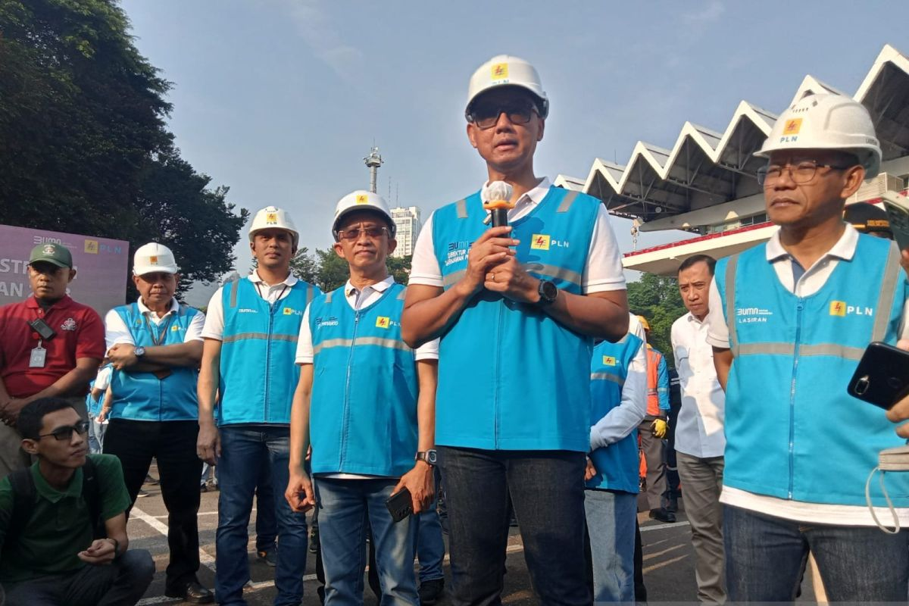

President Director of PT PLN (Persero) Darmawan Prasodjo (second from right) at the power readiness roll call for the ASEAN Summit at Istora Senayan, Central Jakarta on Thursday (08/31/2023). (ANTARA/Farhan Arda Nugraha)

